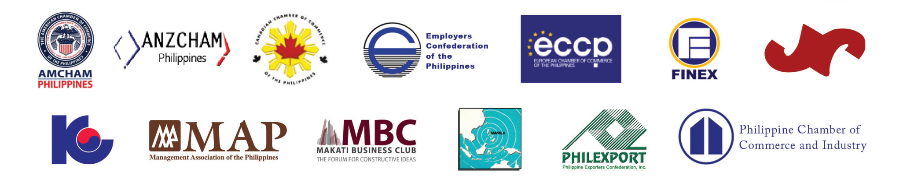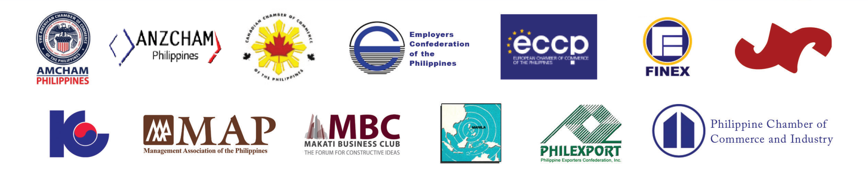

**Philippine Business Groups**

**Joint Foreign Chambers of the Philippines**

**PRESS CONFERENCE**

**MEDIA REPLY FORM**

**What: *Joint Foreign Chambers–Philippine Business Group–Industry Associations***

***Press Conference on Responsible Mining: Realizing Its Potentials***

**When: *September 10, 2014 [9:30am- 12nn]***

**Where: *AIM Conference Center Manila (ACCM), J.V. del Rosario Bldg., Benavidez corner Trasierra Sts., Legaspi Village, Makati City***

**----------------------------------------------------------------------**

Name : _____________________________________________

Designation : _____________________________________________

E-mail Address : _____________________________________________

Company : _____________________________________________

Address : _____________________________________________

Contact No. : _____________________________________________

----------------------------------------------------------------------

**RSVP**

**Kent Marjun B. Primor/ Froland M. Tajale**

Government Liaison/AmDesk Specialist/Research Associate  
American Chamber of Commerce of the Phils. Inc.  
Tel #: 818-7911 to 13; 818-7911 to 222, Fax: 811-3081

Email: [kent@amchamphilippines.com](mailto:kent@amchamphilippines.com); [froland@arangkadaphililppines.com](mailto:froland@arangkadaphilippines.com)